The Magic of the GPT Intune Device Troubleshooter

I am more than happy to release my new tool the GPT Intune Device Trouleshooter. Wouldn’t it be awesome if you have an assistant which you explain what you want to do in Intune an he do the job for you? This dream will now become reality with the GPT Intune Device Troubleshooter.

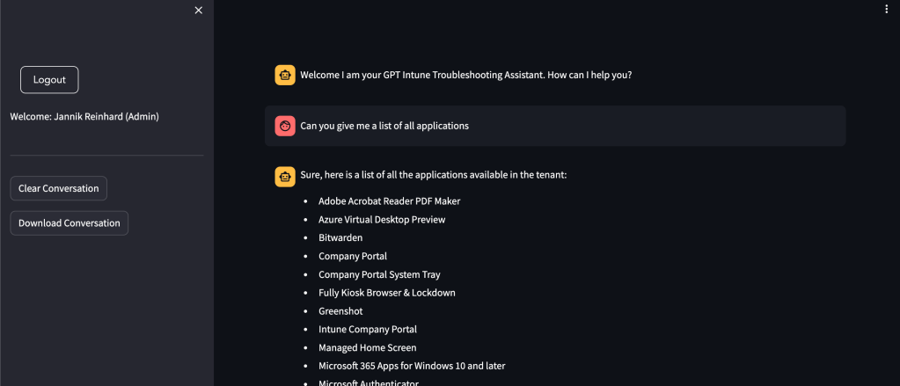

Content

1. [Content](https://jannikreinhard.com/2023/09/10/the-magic-of-the-gpt-intune-device-troubleshooter/#content)
2. [What is the GPT Intune Device Troubleshooter](https://jannikreinhard.com/2023/09/10/the-magic-of-the-gpt-intune-device-troubleshooter/#what-is-the-gpt-intune-device-troubleshooter)
3. [What are the prerequisites](https://jannikreinhard.com/2023/09/10/the-magic-of-the-gpt-intune-device-troubleshooter/#what-are-the-prerequisites)
4. [How does it work](https://jannikreinhard.com/2023/09/10/the-magic-of-the-gpt-intune-device-troubleshooter/#how-does-it-work)
5. [Get access to Open AI Service](https://jannikreinhard.com/2023/09/10/the-magic-of-the-gpt-intune-device-troubleshooter/#get-access-to-open-ai-service)
6. [How it the data privacy when I use the Azure Open AI service](https://jannikreinhard.com/2023/09/10/the-magic-of-the-gpt-intune-device-troubleshooter/#how-it-the-data-privacy-when-i-use-the-azure-open-ai-service)
7. [How to deploy the GPT Intune Device Troubleshooter](https://jannikreinhard.com/2023/09/10/the-magic-of-the-gpt-intune-device-troubleshooter/#how-to-deploy-the-gpt-intune-device-troubleshooter)
8. [What is the current feature sets and what are example calls](https://jannikreinhard.com/2023/09/10/the-magic-of-the-gpt-intune-device-troubleshooter/#what-is-the-current-feature-sets-and-what-are-example-calls)
9. [How to create the app registration](https://jannikreinhard.com/2023/09/10/the-magic-of-the-gpt-intune-device-troubleshooter/#how-to-create-the-app-registration)
10. [Post setup steps](https://jannikreinhard.com/2023/09/10/the-magic-of-the-gpt-intune-device-troubleshooter/#post-setup-steps)
11. [How to open the Webpage](https://jannikreinhard.com/2023/09/10/the-magic-of-the-gpt-intune-device-troubleshooter/#how-to-open-the-webpage)
12. [How does the Tool work](https://jannikreinhard.com/2023/09/10/the-magic-of-the-gpt-intune-device-troubleshooter/#how-does-the-tool-work)
13. [How you can contribute?](https://jannikreinhard.com/2023/09/10/the-magic-of-the-gpt-intune-device-troubleshooter/#how-you-can-contribute)
14. [How does the roadmap look like?](https://jannikreinhard.com/2023/09/10/the-magic-of-the-gpt-intune-device-troubleshooter/#how-does-the-roadmap-look-like)

What is the GPT Intune Device Troubleshooter

The GPT Intune Device Troubleshooter is a powerfull tool which helps Intune admins to make here day easier. It answers your free text questions based on your enviroment utilizing graph api. You can ask questions like “Can you check the status of the device XXXX” or “Can you give me a device list with all android devices in csv” and you will get the customised answer to your question.

What are the prerequisites

* GPT enabled Subscription
* App registration with deligated permissions for (*DeviceManagementConfiguration.Read.All, DeviceManagementManagedDevices.Read.All, DeviceManagementApps.Read.All, User.Read*)

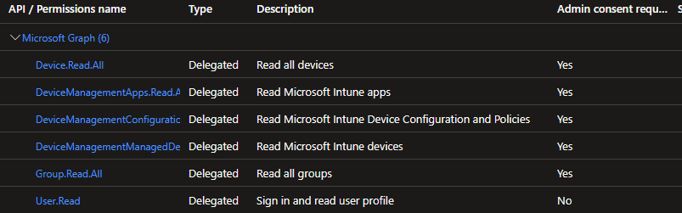

How does it work

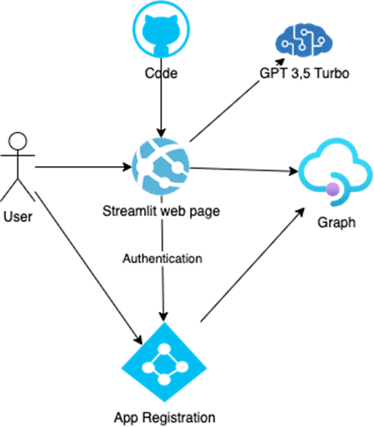

* You can deploy the infrastructure with one click from GitHub to azure
* The code will be pulled to the app service
* The user open the streamlit web page
* The user authenticate via a app registration with delegated permissions for graph
* This token will be used to get data from graph and put them into an prompt
* This prompt with question and enriched informations will be send to the open ai service
* The answer will be presented on the streamlit web page

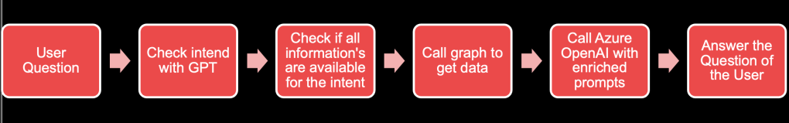

Get access to Open AI Service

Fill out the following [request form](https://customervoice.microsoft.com/Pages/ResponsePage.aspx?id=v4j5cvGGr0GRqy180BHbR7en2Ais5pxKtso_Pz4b1_xUOFA5Qk1UWDRBMjg0WFhPMkIzTzhKQ1dWNyQlQCN0PWcu) to enable you subscription to deploy open ai services.

How it the data privacy when I use the Azure Open AI service

You can finde more information about privacy in this [MS doc](https://learn.microsoft.com/en-us/legal/cognitive-services/openai/data-privacy).

How to deploy the GPT Intune Device Troubleshooter

You dont have to do so much. The whole magic is behind this button.

[Deploy to Azure](https://portal.azure.com/#create/Microsoft.Template/uri/https%3A%2F%2Fraw.githubusercontent.com%2FJayRHa%2FGPTDeviceTroubleshooter%2Fmain%2Fazuredeploy.json)

But you can also deploy the infratructure and the code manual via my [github repository](https://github.com/JayRHa/GPTDeviceTroubleshooter).

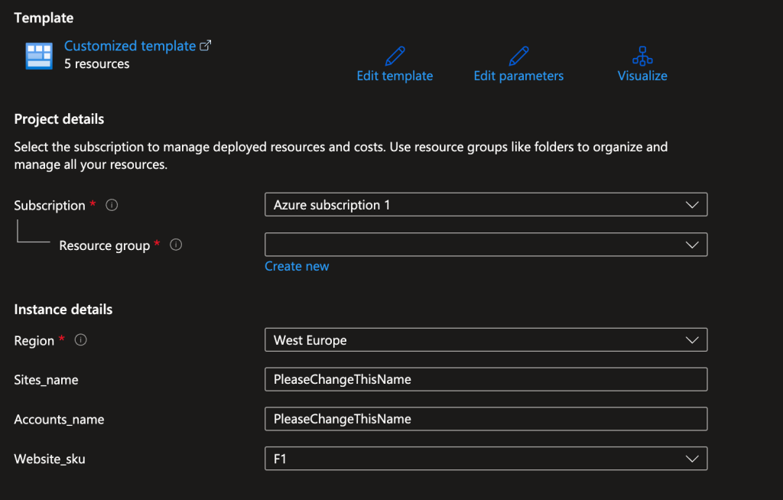

* Select the subscription and the resource group
* Select the region and the Website sku
* Enter an name for the site and the open ai service account

What is the current feature sets and what are example calls

Currently the following features are supported:

* Get Device List
* Get Device Status
* Get Single Device
* Intune How To
* Config Profiles
* App List
* Compliance Policies
* Device Group Membership
* Graph Call

Examples are:

* Can you give me a device list with all android devices in csv
* Can you check the status of the device XXXXX
* Can you check the status of the device XXXX and list the object which has conflict or have errors
* Can you give me a list of all applications
* Can you show me a list in csv of all apps which are created later than 01.01.2022
* In which groups is XXXX? Can you give me the display name and the ids

How to create the app registration

* Open the [Entra portal](https://entra.microsoft.com/#home)
* Select **App registration**

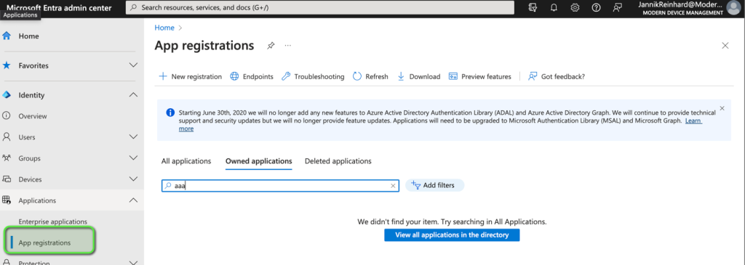

* Click **+ New registration**
* Enter an name for the App registration
* Select Single-Page application (SPA) as redirect type
* Add https://***WEBPAGENAME***.azurewebsites.net/login/callback as Redirect URI

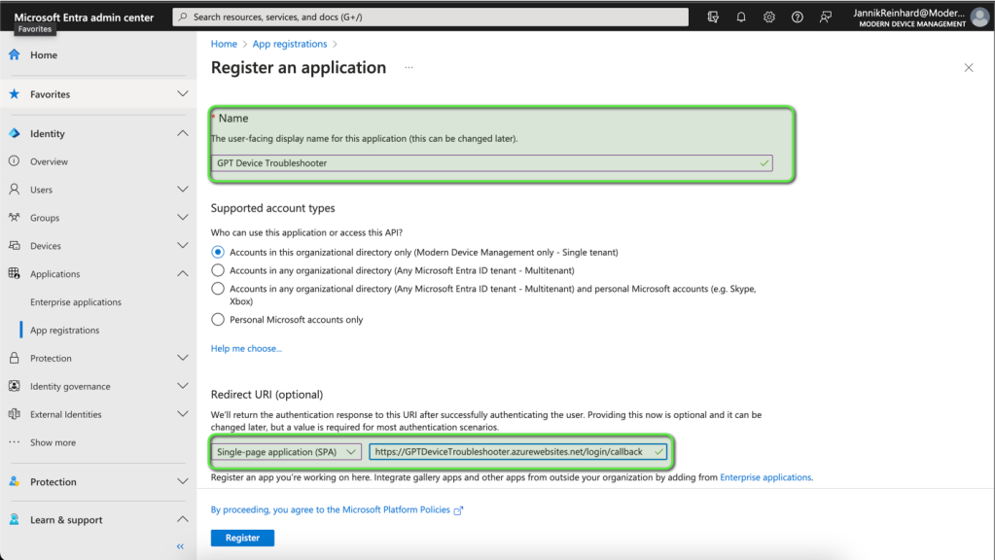

* Copy the **App ID**

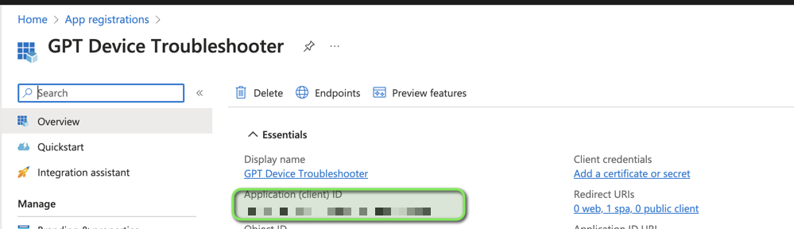

* Go to **API permissions**and click **+ Add a permission**

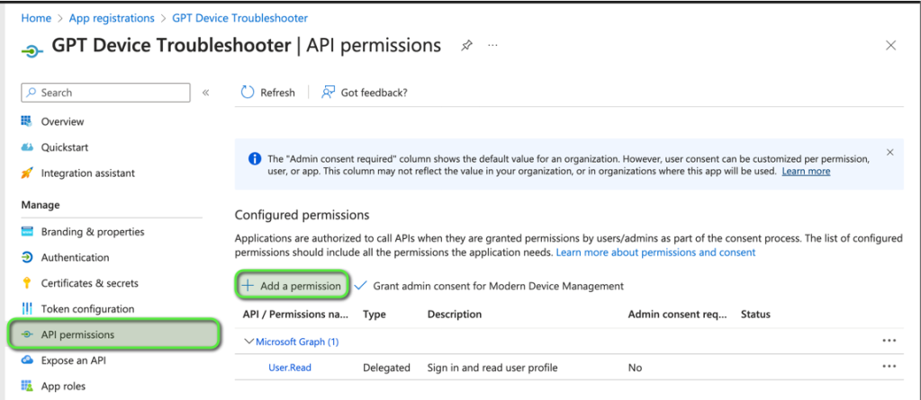

* Select Graph

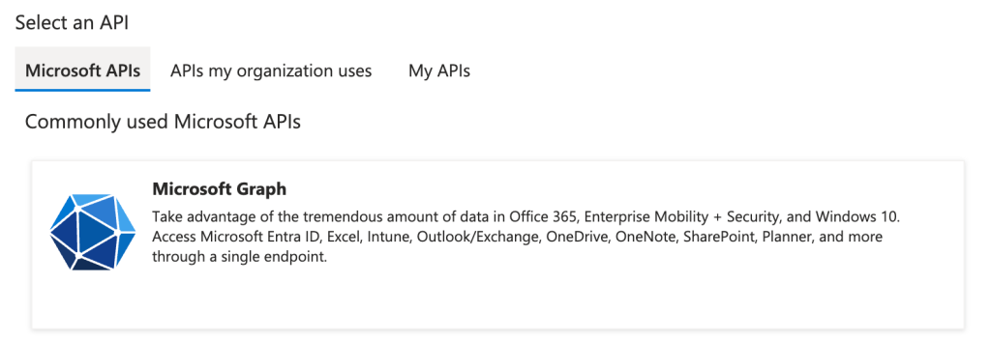

* Select Delegated permissions

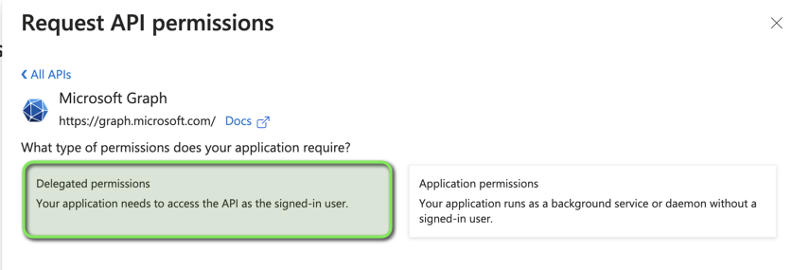

* Add the following permissions (*DeviceManagementConfiguration.Read.All, DeviceManagementManagedDevices.Read.All, DeviceManagementApps.Read.All, Group.Read.All, User.Read, Device.Read.All*)
* Click Grant admin consent for XXX

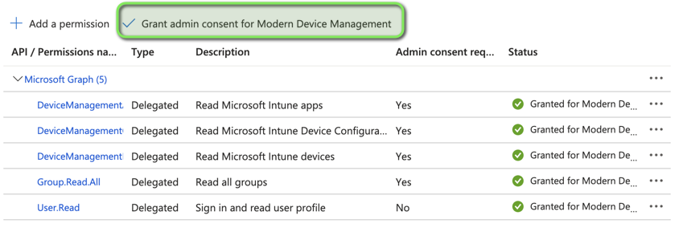

Post setup steps

Add the App ID and the secret from the OpenAi Service to the Variables in the App Service Configuration

* Open the Open Ai Service

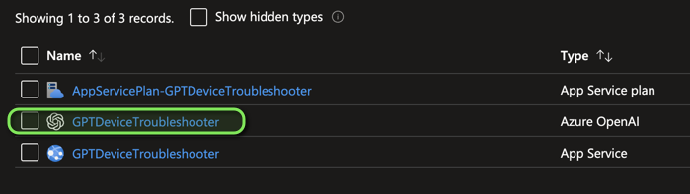

* Go to Keys and Endpoint

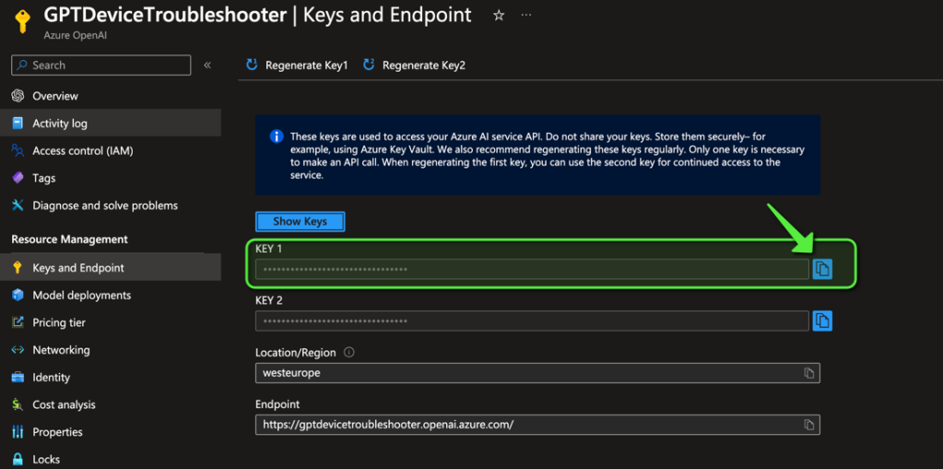

* Open the App Service

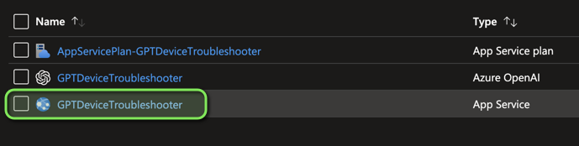

* Navigate to Configurations
* Fill in the Azure open AI key and the App Id into the variables

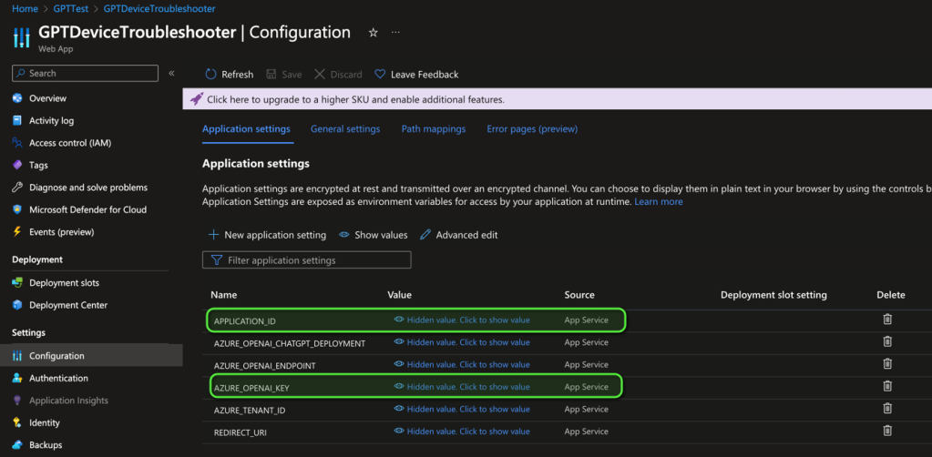

How to open the Webpage

* Go to the App Service and Select **Browse**

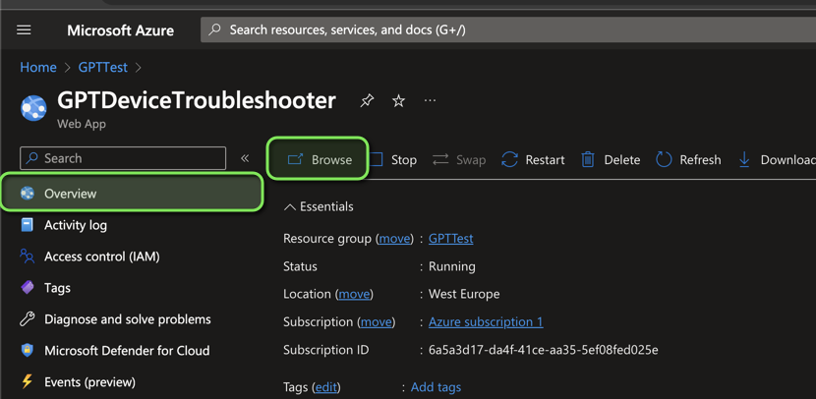

How does the Tool work

* Click on login to get an Token to authenticate on graph

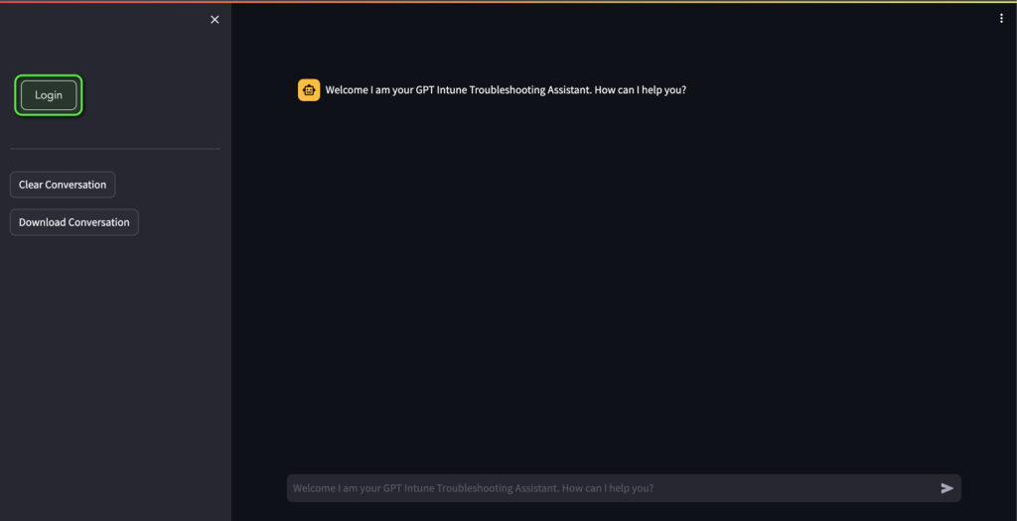

* Insert your question in the chat box

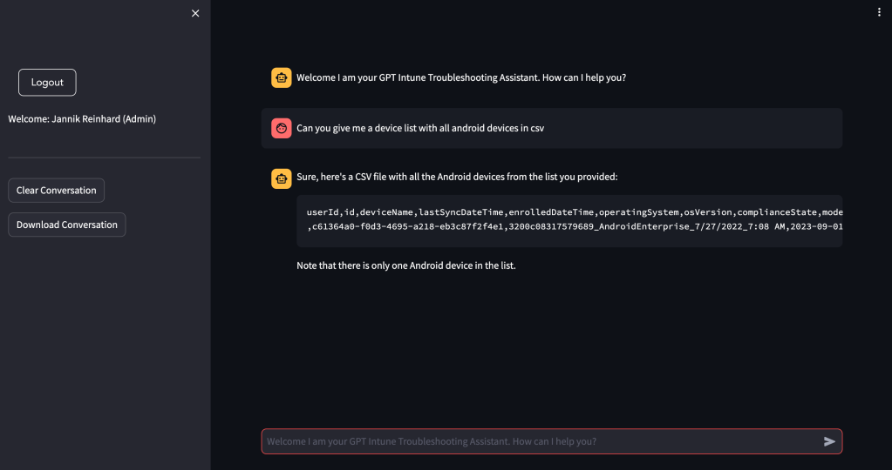

How you can contribute?

If you have a ideas for improvements or for missing features as well as bugs, contact me via my blog, social media or open an issue on the repository with an description of your idea. You can also create merge request. I am happy for every contribution and feedback.

How does the roadmap look like?

Please provide me feedback. Based on your feedback I will include and prioritise the features I will add.

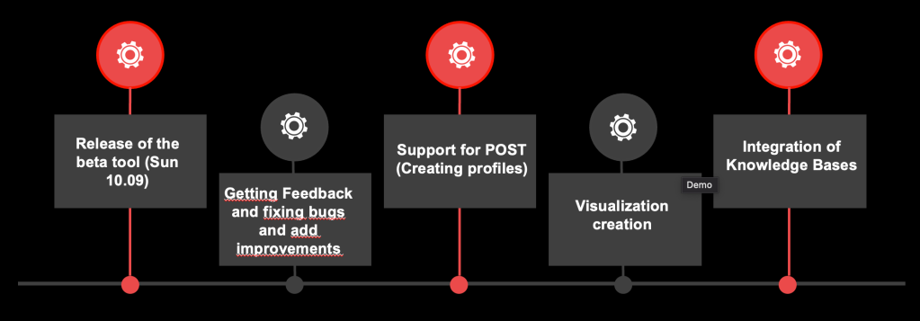

**Share this:**

* [Click to share on Twitter (Opens in new window)](https://jannikreinhard.com/2023/09/10/the-magic-of-the-gpt-intune-device-troubleshooter/?share=twitter&nb=1)
* [More](https://jannikreinhard.com/2023/09/10/the-magic-of-the-gpt-intune-device-troubleshooter/)

**Related**

[IME Log summarizer](https://jannikreinhard.com/2024/07/28/ime-log-summarizer/?relatedposts_hit=1&relatedposts_origin=5046&relatedposts_position=0)28. July 2024In "AI"

[GPT Remediation creator](https://jannikreinhard.com/2024/01/07/gpt-remediation-creator/?relatedposts_hit=1&relatedposts_origin=5046&relatedposts_position=1)7. January 2024In "All"

[Introduction of the Intune Device Troubleshooter](https://jannikreinhard.com/2022/07/31/introduction-of-the-intune-device-troubleshooter/?relatedposts_hit=1&relatedposts_origin=5046&relatedposts_position=2)31. July 2022In "All"

[AI](https://jannikreinhard.com/tag/ai/), [Apps](https://jannikreinhard.com/tag/apps/), [Configuration Profiles](https://jannikreinhard.com/tag/configuration-profiles/), [Deployment](https://jannikreinhard.com/tag/deployment/), [Enrollment](https://jannikreinhard.com/tag/enrollment/), [GPT](https://jannikreinhard.com/tag/gpt/), [Intune](https://jannikreinhard.com/tag/intune/), [Powershell](https://jannikreinhard.com/tag/powershell/), [Windows](https://jannikreinhard.com/tag/windows/)

Post navigation

[Previous Post](https://jannikreinhard.com/2023/08/13/new-version-of-the-intune-group-assignment-script/)

[New Version of the intune group assignment script](https://jannikreinhard.com/2023/08/13/new-version-of-the-intune-group-assignment-script/)

[Next Post](https://jannikreinhard.com/2023/10/08/how-to-enroll-device-to-microsoft-defender-for-endpoint-and-how-does-it-work-1-2/)

[How to enroll device to Microsoft Defender for Endpoint and how does it work (1/2)?](https://jannikreinhard.com/2023/10/08/how-to-enroll-device-to-microsoft-defender-for-endpoint-and-how-does-it-work-1-2/)

22 thoughts on “The Magic of the GPT Intune Device Troubleshooter”

1. [**Deep Dive into Co-Pilots: Understanding Architecture, LLMs, and Advanced Concepts – Modern Device Management**](https://jannikreinhard.com/2023/12/11/deep-dive-into-co-pilots-understanding-architecture-llms-and-advanced-concepts/) says:

[11. December 2023 at 18:59](https://jannikreinhard.com/2023/09/10/the-magic-of-the-gpt-intune-device-troubleshooter/comment-page-4/#comment-2464)

[…] <https://jannikreinhard.com/2023/09/10/the-magic-of-the-gpt-intune-device-troubleshooter/> […]